WEEKS FIVE & SIX: Horror/Mystery/Romance/Comedy

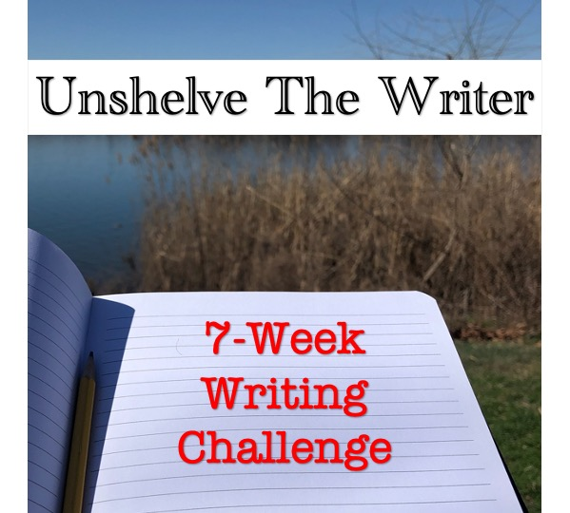

We’re combining weeks five and six into one prompt, while we continue to explore genre fiction. Utilize the following prompt to create a 500-1,000 piece (no word count for poetry) and then email UnshelveTheWriter@gmail.com if you would like feedback from the other writers or wish to have your finished piece posted online.

- Pick two of the following genres (Horror, Mystery, Romance, Comedy) to craft an unconventional story or refresh a work in progress. Let creativity guide your words. Have fun! Get creative! WRITE!!!!

